3SDW Project Management and Data Request Specification

Overview
This document is a design specification for project management and data package requests for the Three State Data Warehouse (TSDW or 3SDW), specifically for NEPA analyses.

Goals:
- Allow project sponsors to specify a minimal set of modeling parameters and background information to initialize a NEPA analysis project.
- Allow project collaborators to request data packages from the 3SDW within the context of a sponsored NEPA analysis project.
- Allow project collaborators to specify analysis goals, standards, protocols, assessments, etc as appropriate.
- Allow data requestors to confirm that they have received valid data following a request.
- Allow project sponsors to monitor the progress of a data transfer and/or analysis project.
- Allow project sponsors to restrict access to project and data package information to specific users.
- Establish preliminary framework to affiliate NEPA analysis results with a specific project and initial data request.

Use Case Outline:
- Project manager initializes a NEPA analysis project through the Projects Overview page.
- Project manager specifies high level background information and modeling parameters.
- Project manager assigns collaborators to the project. Collaborators must first register for a 3SDW user account.
- Collaborator initializes a data request through the Projects Overview or Project Configuration page.
- Collaborator specifies required analysis goals, standards, protocols, assessments, etc through the NEPA Data Request page. The collaborator may save a request in progress and return to complete the request later.
- Project Manager or other collaborators can monitor the progress of the data request.
- Collaborator submits the NEPA Data Request.
- Optionally 3SDW curators or the Project Manager approve the request.
- Collaborator retrieves Data from 3SDW (data retrieval is not in the scope of this specification)
- Collaborator validates that valid data has been received and signs off on the Data Request either through the Projects Overview or Project Configuration pages.
- Upon completion of the analysis collaborator submits model results to the warehouse through the Project Configuration page. (Future work, not in the scope of this specification)

Interface Mockups:

Projects Overview:

Functionality Provided
- View filtered list of projects; All projects, My Projects, etc
- Create a new Project (Restricted to certain project managers)
- Access project configuration pages (only for project collaborators)
- View Data Request status
- Sign-off a data request for a project (Restricted to data requestor)
- Create a new data request for a project (Restricted to project collaborators)

Mockup
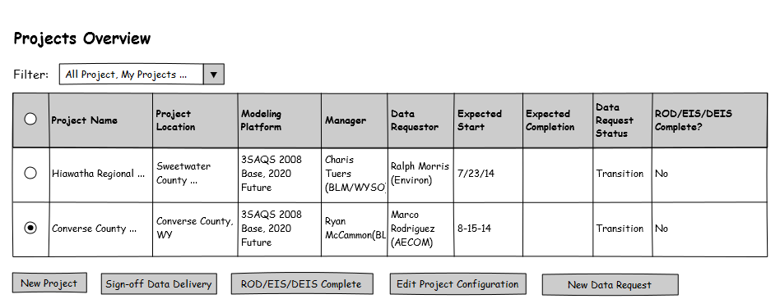
“Project Complete?” would not restrict us to ROD/EIS/DEIS.
Would “Data Transfer Status” make more sense?

Project Configuration:

Functionality Provided
- View/Edit high-level background information and modeling requirements (Restricted to project managers)
- Manage project collaborators (Restricted to project managers)
- View Data Request status
- Resume/Edit a data request (Restricted to data requestor)
- Sign off Data Request (Restricted to data requestor)

Mockup
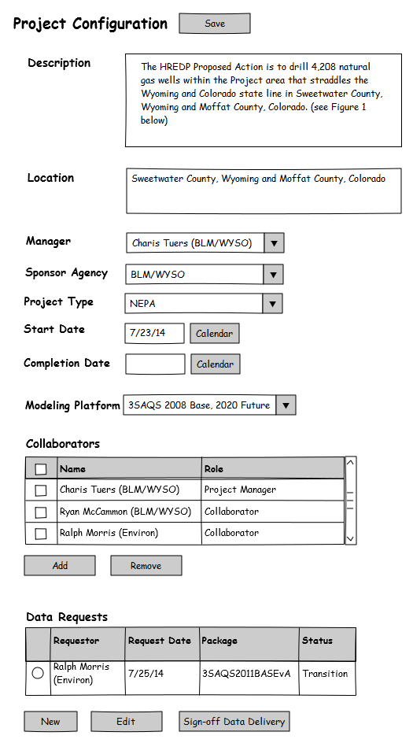
Expected Completion Date

NEPA Data Request

Functionality Provided
- Allow a data requestor to specify modeling parameters and detailed information about the intended analysis.
- Allow a data requestor to specify a data package for retrieval.
- Allow a data requestor to attach supplemental files (diagrams, documents, etc).
- Allow a data requestor to save progress on a data request and submit it at a later time.
- Allow a data requestor to submit a data request.

Mockup
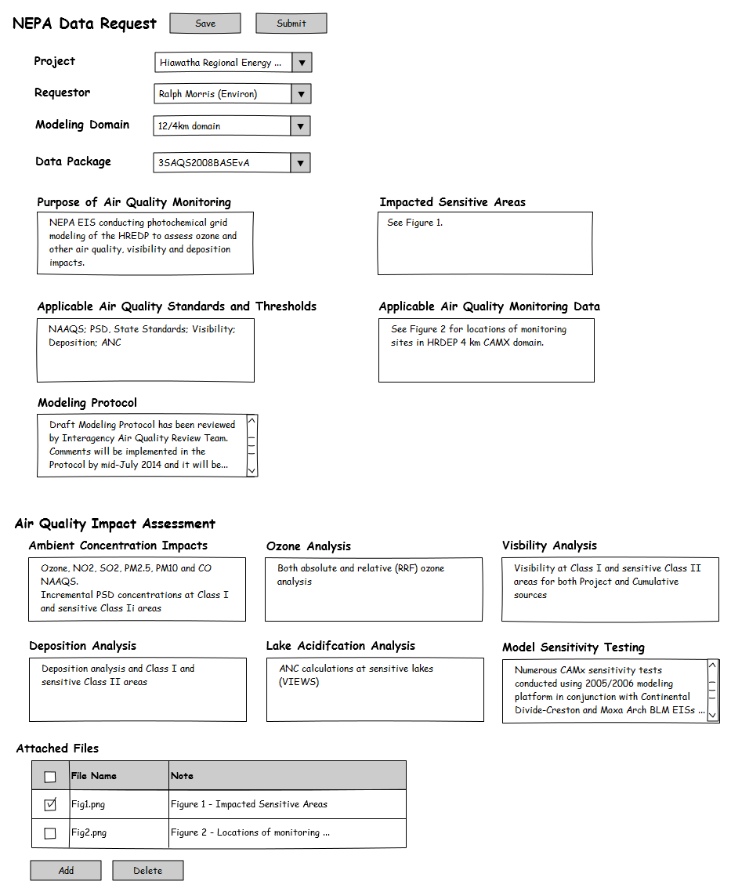
Add option to select the corresponding O3 RRF data package. Something like “Include ozone RRF Data Package?”. Per discussions, this should be part of the NPEA package, but provided separately. Possible content includes base year model results, guidance for generating RRFs, and scripts for formatting future year model results so formats are comparable to base year results provided.
We talked about only asking for Modeling Protocol Status with a checklist, and having space for comments. Checklist might include (In Preparation; Submitted for Review; Final Draft Complete but not Available for Release; Finalized Draft Available for Release; N/A)
Need to identify CAMX either in the Data package title (e.g. CAMX 3SAQS2008BASEvA) or as an additional selectable option (e.g. select CAMX or CMAQ)

